   

**e-Yantra Robotics Competition – 2018**

**Theme and Implementation Analysis – Ant Robot**

**#226**

|  |  |
| --- | --- |
| **Team leader name** | **Karthik K Bhat** |
| **College** | **PES University** |
| **Email** | **karthikkbhat19@gmail.com** |
| **Date** | **30 December 2018** |

**Scope and Preparing the Arena**

**Q1. a. State the scope of the theme assigned to you.**

**(5)**

The theme mimics the organized working of the ants. Ant robots are to work as a service provider for ant hills. They are supposed to search, collect and store the materials in ant hills. This theme helps us understand the organized and efficient in which a robot works. The scope of the theme can also be applied in industrial warehouses where intensive labor and precision is required and in subtle places like libraries where any sort of errors can be avoided. The application can extend to areas where manual labor can be replaced where only a little thinking is required.

**b. Upload the Final Arena Images.**

**(20)**



**Building Modules**

**Q2. Identify the major components required for designing the robotic system for the theme assigned to you.**

**(5)**

**Electrical:**

1. **Raspberry-Pi with Camera**: They are collectively used for identifying the ArUco markers and colored blocks.

The Raspberry-Pi also runs the program to finish the given services.

1. **Line sensor:** This sensor is used to identify the path on the arena. This helps the robot to follow the path.
2. **Arduino Nano:** Arduino Nano is used to read the values from and controlling the actuators, **LED** and **buzzer**.
3. **Motor controller:** L298N is a dual-channel motor controller, used to power the DC motors as required.
4. **Power source:** To power the robot.

**Actuators:**

1. **DC Motors:** DC Motors with the **wheels** are used for the movement of the robot.
2. **Servo motors with servo blade:** These are used for:
3. Pick and place mechanism
4. Camera Roll motion

**Other Components:**

1. **Robot Chassis:** Used to support the different components placed on the robot like the Raspberry-Pi, PiCamera, Arduino and power supplies etc.
2. **Metal strips:** Used for the pick and place mechanisms.

**Power Management**

**Q3. a. Explain the power management system required for a robot in general and for the theme assigned to you.**

**(5)**

From Appendix-1, we infer that maximum current of 5.6A may be drawn at a point of time. Current drawn when the robot is idle is less than 2 A. To run the robot continuously for 30 minutes with a single power supply, we would need a battery of 2000mAh capacity that provides high current.

Here, we will be powering the DC Motors with the 12V battery. The power-bank (with 2A outputs) will be used to power the Raspberry-Pi and the servos. Arduino will be connected to the Raspberry-Pi through USB, which also establishes a serial communication between them.

**b. Can there be a single power supply for your robot? - Yes/No/Don’t know. Please elaborate/justify your answer choice.**

**(5)**

Yes, there can be a single power supply, if we can use a Buck converter.

We should use a 12V battery and regulate the voltage to 5V. This is because the components like Raspberry-Pi, Arduino works at 5V and the motors work at 12 V.

A linear voltage regulator like 7805 provides a current output of 1.5 A, which is not enough to power the servo motors, Arduino and the Raspberry-Pi.

Buck converters, unlike the linear voltage regulators, provide higher current output. So, we should use a buck converter to regulate the voltage.

However, a single power-supply would mean that it must provide high current and higher capacity. To reduce heavy loading on single power supply, we have opted for dual power supply – 12V battery and power-bank for our robot as explained in the previous question.

**Design Analysis**

**Q4.** **Team have to design a robot which traverses the arena following a given path.**

1. **How will you design a robot to traverse the arena given in the rulebook?**

**(5)**

The inputs will be the images of the SIMs, colored blocks and a signal that states if the robot has reached a node. Based on these inputs, the output will be the Aruco ID after processing the image, control signal to the pick and place mechanism and the path to follow respectively.

To get the required inputs, we will be using a line following sensor that is placed facing the flex. This provides a signal that states if the robot has reached the node and keeps the robot on the track. A pi camera that can be controlled using a servo motor is used to capture the images of the sim and the colored blocks.

**b. How many actuators do you feel are sufficient for designing a pick and place mechanism? If you are going to use additional actuators (apart from those provided in the kit), how and for what purpose do you plan to use them?**

**(5)**

A single servo motor is sufficient to design a pick and place mechanism. We used a four-link mechanism to achieve the same.

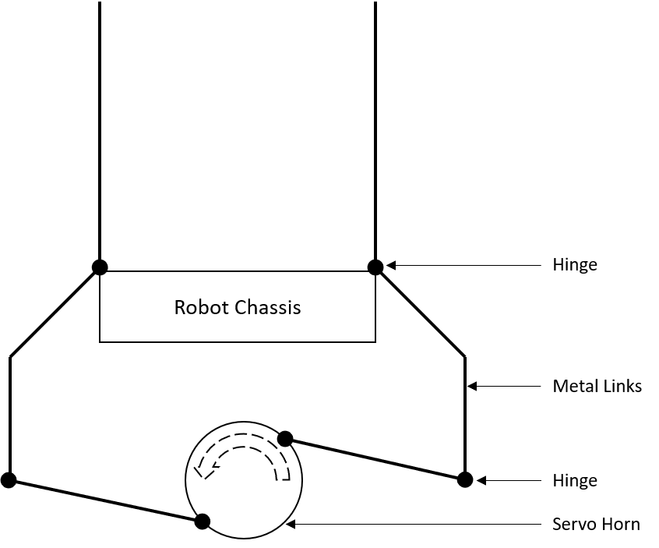

**Environment Sensing**

**Q5. a. Explain how you will use the Line Sensor to decide the course of traversal (identifying line and nodes).**

**(5)**

Initially, when the robot is placed at the start, the three-channel line sensor starts sending the values. If it detects black line, it should produce a low voltage and the detection of white color produces a comparatively high voltage.

So, the possible combinations of things being detected by left, middle and right sensor are as follows:

1. When all the three sensors detect black line, it might be central node or a node near the ant hills or Trash zone. The robot turns according to the needs. Now, the robot just travels a very small distance, if the middle sensor detects black line and the other two white color it is the Central Node (CN). After travelling a small distance if all the three sensors detect white color then it is the Regular Node (RN).
2. When the left and right sensor detects white color and the middle sensor detects black line it is detected as path and the robot starts travelling straight.
3. When the middle sensor and any of the corner sensors detect black line, this indicates a node near the shrubs area. The robot turns in the direction in which the corner sensor detects black line.

**b. Would the webcam be a better choice of camera over the PiCam? Explain.**

**(5)**

PiCamera is better choice over a Webcam for the following reasons:

**Pros of using PiCam:**

1. PiCam has a better resolution when compared to a webcam. It has the capability to shoot 1080p 50fps video.
2. It has a higher framerate as it uses Graphics Processing Unit (GPU) present in the Raspberry-Pi.
3. It makes use of the high-speed Camera-Serial Interface (CSI) Port.

**Cons of using webcam:**

1. The resolution is not as good as PiCam.
2. Comparatively, lower framerates.
3. It is limited by the speed of a Universal Serial Bus (USB) 2.0 Port
4. They use the Central Processing Unit (CPU) instead of the GPU

**Pros of using webcam:**

1. Focusing the objects is easier when compared with the PiCam
2. Webcam is more versatile

**c. What other sensors will the robot require to complete its task successfully?**

**(5)**

According to our design and implementation, we do not require any additional sensors to complete the given task.

If we could use any additional sensors, we would have used an **IR sensor** or an **ultrasonic sensor** to make sure the robot does not touch the walls, thereby avoiding any penalty.

We would have also used an **optical interrupt sensor** (slot sensor) as a wheel speed encoder, to increase the precision of the robot’s movements.

**d. Explain the strategy you will follow to detect and indicate the SIM placed around the Central Node (This includes traversing strategy to reach different SIMs).**

**(4)**

Our robot’s design provides option for the camera to turn (roll).

**Step 1**: The robot at the beginning after reaching the Central Node (CN) traverses a few centimeters towards the ‘trash zone’, so that it is in line with SIM0 and SIM1. The camera is made to face downward.

**Step 2**: The robot turns 90 degrees anticlockwise and then reads SIM0.

**Step 3**: From there the robot turns 180 degrees clockwise and then reads SIM1.

**Step 4**: Now it turns 90 degrees clockwise and traverse until it reaches the central node.

**Step 5**: From there it travels a few centimeters towards the ‘start’

**Step 6**: To read SIM2 and SIM3, it follows similar steps as explained in Step 2 and Step 3.

**Testing your Understanding (Theme Analysis and Rulebook-related)**

**Q6. a. If at a given SIM location ArUco ID is found to be 76 (Decimal), what is the Ant Hill Number and type (Regular Ant Hill or Queen Ant Hill) and what are the Service Requirements of this Ant Hill?**

**(3)**

**Ant Hill Number:**AH2

**Ant Hill Type:** Regular Ant Hill

Trash removal is not required

**Service Requirement at Serv 1:** Leaves (Green block should be placed at Serv 1)

**Service Requirement at Serv 2:** Honey dew (Red block should be placed at Serv 2)

**b. Is SIM0: 25, SIM1: 60, SIM2: 217, SIM3: 226, a possible combination of SIMs to be placed on the arena? If not explain with reasons.**

**(3)**

No, this is a wrong combination of SIMs that can be placed on the arena

**Reason 1**: SIM 0 and SIM 1 robot are pointing to the same ant hill that is AH0. So, SIM1 must be altered in such a way that it points to AH1.

**Reason 2:** There are two QAH (Queen ant hill) namely AH2 and AH3. Since, there can be only one QAH, this is not a proper combination of SIM.

**Reason 3:** Three anthills require four woods (blue blocks). This violates the rule which says only maximum of 2 of any kind can be placed in the shrubs area.

**c. What are the different conditions that indicate end of a run?**

**(3)**

The different conditions that indicate the end of run are:

**Condition 1:** When the maximum time limit of 600 seconds is reached, it indicates the end of run.

**Condition 2:** When the ant robot completes the task, return to the start and turns on the buzzer for 5 seconds.

**Condition 3:** If the team has used the maximum number of chances of repositioning and requires another repositioning, it indicates the end of the run.

**Algorithm Analysis**

**Q7. Draw a flowchart illustrating the algorithm you propose to use for theme implementation (10)**

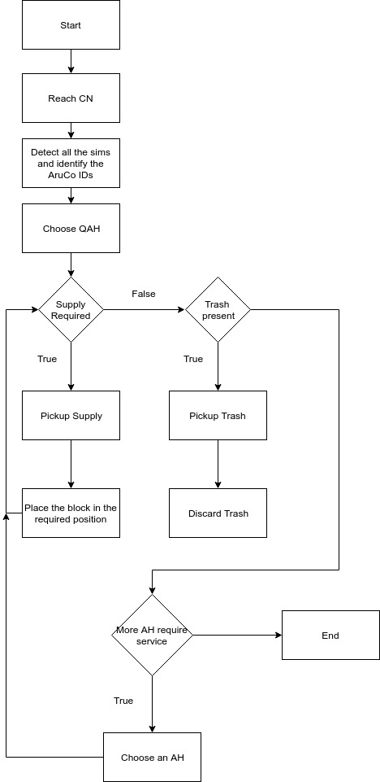

**Q8. Suppose for a given arena configuration, it takes 20 seconds more to execute the task while keeping the Queen Ant Hill in priority. What will be your logic to traverse the arena in order to secure maximum marks i.e. you will serve Queen Ant Hill first by taking 20 seconds more or complete the run faster by not serving Queen Ant Hill first (Assuming, points scored for all other parameters in Total Score in robot the cases remain same). Please explain and justify your logic and strategy.**

**(4)**

Since the total score remains same in both cases, it is better to service the Queen Ant Hill (QAH) first. Taking 20 seconds more to complete the run results in getting 20 points less. But servicing the QAH first fetches 100 points for QB (Bonus for servicing Queen Ant Hill) and possibly 300 points more in the Overall Bonus (provided the task is completed with no penalties). However, we should make sure that the run can be completed within the given time limit while keeping the Queen Ant Hill in priority.

**Challenges**

**Q9. What are the major challenges that you can anticipate in addressing this theme and how do you propose to tackle them?**

**(8)**

1. Detection of coloured blocks and Aruco with camera:

The major problem in detection is that aruco is to be scanned horizontally whereas the coloured blocks vertically. Also, while detecting the colour of the blocks, it is inefficient to make the robot move to detect each supply. All these problems can be tackled if we the camera is mounted onto a servo for rotation. We can scan multiple blocks at once and change camera's orientation as required.

1. Precise movements of the robot:

Align robot while picking the supplies with the help of camera feedback so that the robot picks the supplies perfectly and does not fail if they are not in position.

1. Finish all the service in the fastest time possible:

Develop an efficient algorithm such that the robot scans the Aruco id and understand the services. Scan the blocks in the fastest way possible and remember their location. Search for ant-hills where service can be completed in a single-visit.

1. Design efficient, reliable pick and place mechanism:

Use the camera feed to align the robot’s pick and place mechanism to hold the block at the desired position. The pick and place mechanism must be simple, yet fast.

**Appendix**

**Appendix – 1**

|  |  |  |  |  |  |  |
| --- | --- | --- | --- | --- | --- | --- |
| **Sl. No.** | **Component** | **Max. Current drawn**  **(A)** | **Voltage rating**  **(V)** | **Quantity** | **Max. Power rating**  **(W)** | **Remarks** |
| 1 | Raspberry-Pi (Model 3 B+) | 1.2 | 5 | 1 | 6 | Maximum total USB peripheral current draw |
| 2 | Arduino Nano | 0.2 | 5 | 1 | 1 | IO pins giving 200 mA each |
| 3 | 12V 100 RPM DC Motor | 1.0 | 12 | 2 | 24 | Considering with Robot’s load |
| 4 | Standard Servo  GS-5515 MG | ^0.2  *2.0 | 5 | 1 | ^ 1  *10 | - Current considered at idle (^) and running (*)  - No Load |
| 5 | Micro Servo | ^10 m  *200 m | 5 | 1 | ^ 50  *200 |
| 6 | Buzzer | 10 m | 5 | 1 | 50 |  |
| 7 | Line Sensor | 16 m | 3.3 | 1 | 53 |  |